**XC-NK-SJ-300 Product Data Sheet**

**Antenna Extensible Cable with Adapters**

**N-K to SMA-J**

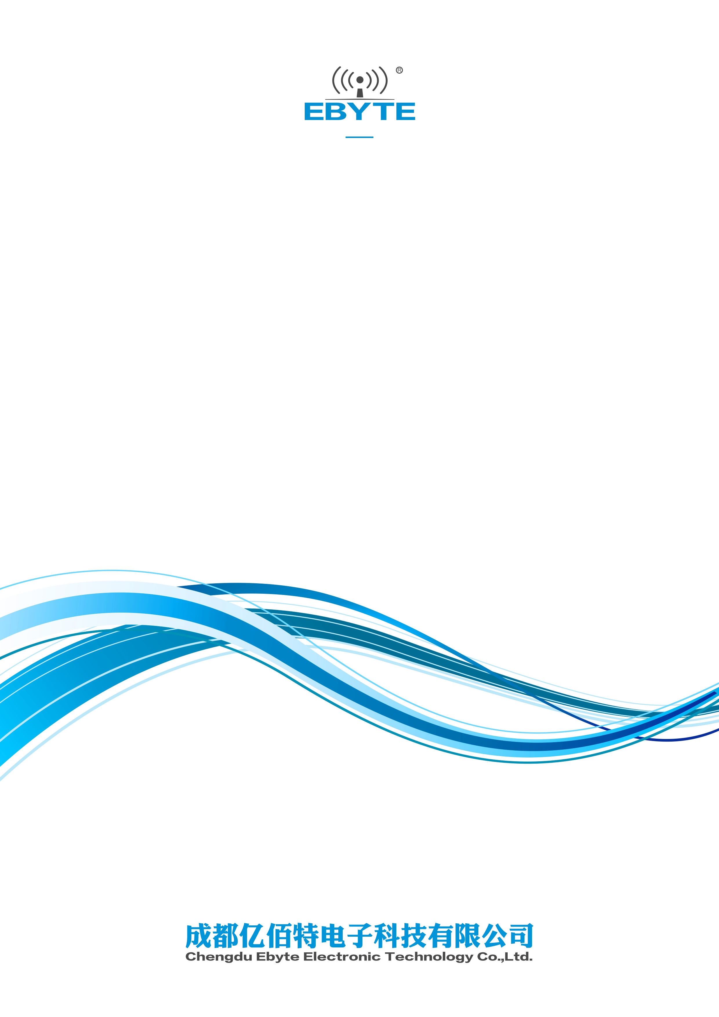

# I. Product Introduction

XC-NK-SJ-300 is a 3m antenna extensible cable with N Female and SMA Male adapters. It can be applied to fiberglass antenna, sucker antenna with the N-type adapter.

# **C:\Users\86187\Desktop\图片1.png图片1**II. Specification and Parameters

|  |  |
| --- | --- |
| **Physical Parameters** | |
| Bandwidth | 0-6000MHz |
| Input Impedance | 50Ω |
| Power Capacity | 100W |
| **Other Parameters** | |
| Cable Length | 3m |
| Total Weight | 113g |
| Cable Material | RG58 |
| Connector | N-K to SMA-J |
| Working Temperature | -40℃～+85℃ |
| Storage Temperature | -40℃～+85℃ |

**IV. FAQ**

* Antenna frequency shall be matched with that of the wireless devices, or the communication will be affected;
* Diffraction performance will be better with lower communication frequency and longer wave;
* Communication distance will be shorter if there is any straight-line barrier;
* Please be noted of the antenna radiation direction. Incorrect direction by installation will result in short communication distance;
* As radio wave may be absorbed by the ground, result will be affected if tested close to ground. It is suggested to test at a higher place;
* As radio wave can be highly absorbed by the ocean water, result will be affected if tested close to the sea;
* Signal will be seriously weakened if the antenna is put close to metal or inside metal shell;
* Lower impedance matching of antenna and communication devices will result in bad communication.

# **About us**

Technical support: [support@cdebyte.com](mailto:support@cdebyte.com)

Documents and RF Setting download link: [www.ebyte.com](http://www.cdebyte.com)

Thank you for using Ebyte products! Please contact us with any questions or suggestions: info@cdebyte.com

------------------------------------------------------------------------------------------------------------

Fax: 028-64146160 ext. 821

Web: [www.ebyte.com](http://www.cdebyte.com)

Address: Innovation Center D347, 4# XI-XIN Road,Chengdu, Sichuan, China

